The Advice Tree

Requirements Document
Version 1

February 10, 2013

Group members:
Dale Alberts
Timothy Cao
Taylor Comer
Benjamin Holley
Christian Morrison

Group 1

Instructor:
Rikk Anderson

Table of Contents

1. Introduction .......................................................................................................................................................... 5
1.1. Purpose .......................................................................................................................................................... 5
1.2. Definitions, Acronyms, and Abbreviations .....................................................................................................5
1.3. References ..................................................................................................................................................... 5
2. System Overview ................................................................................................................................................. 6
2.1. Purpose ........................................................................................................................................................ 6
2.2. Use Case Diagram ....................................................................................................................................... 6
3. Specific Requirements......................................................................................................................................... .7
3.1 Seek Advice[Category]………………………………………………………………………………………....7
3.1.1 Description
3.1.2 Actors
3.1.3 Steps
3.2 Add Advice[User]……………………………………………………………........……………………………7
3.2.1 Description
3.2.2 Actors
3.2.3 Steps
3.3 Blocking Flagged Content[Admin]……………………………………………………………………………8
3.3.1 Description
3.3.2 Actors
3.3.3 Steps
3.4 Rate an Advice[User].....................……………………………………………………………………………8
3.4.1 Description
3.4.2 Actors
3.4.3 Steps
3.5 Register as a User[Guest]...............……………………………………………………………………………9
3.5.1 Description
3.5.2 Actors
3.5.3 Steps
3.6 Delete an Advice[User][Admin].....……………………………………………………………………………9
3.6.1 Description
3.6.2 Actors
3.6.3 Steps
Appendix A: User Interface.................................................................................................................................... 10

Appendix B: Initial Task and Role Assignments.................................................................................................... 17

1. Introduction

  - Purpose

The purpose of this Requirements Document is to specify the software requirements of The Advice Tree, a site where users share advice with other uses whether it be school or life related. This document will explain and define the concept and all steps of The Advice Tree's development.

The intended audience of this document is the software developers, Mr. Anderson, and the CSE faculty.

1.2 Definitions, Acronyms, and Abbreviations

Post To upload an advice for other users to view.

Advice A string of text that contains a sentence of helpful or useful meaning.

Flagging To mark an advice that is demeaning, hateful, or disrespectful for the Administrators
to remove.

Helpful A method for other users to mark if the specific advice was helpful or meaningful.

Unhelpful A method for other users to mark if the specific advice was not helpful or meaningful.

1.3 References

IEEE Std. 830-1998, IEEE Recommended Practice for Software Requirements Specifications, Institute for Electrical and Electronic Engineers, Piscataway, New Jersey, 1998.

Violet UML Editor. Retrieved February 14, 2013, from http://alexdp.free.fr/violetumleditor/page.php.

2. System Overview

2.1 Purpose

The Advice Tree will be a user interactive site where users will post and interact with Advices. The site will display a random Advice on the front page for guests to view but not interact with. Conversely, users will be able to register and log into the site to create their own advice and interact with other Advices. There will be a menu for the current user to post an Advice, view their Advices, and delete their Advices. While viewing an Advice of another user, the current user may comment on, flag, or rate an Advice. The Advice Tree will allow the Administrators of the site to manage each individual Advice with ease to remove any flagged advice.

2.2 Use Case diagram

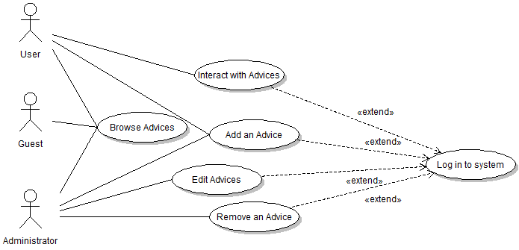

3. Specific Requirements

3.1. Seek Advice by Category(Required)

3.1.1. Description
A member would use this function to look for and generate advice of a certain category.

3.1.2. Actors
User

3.1.3. Steps

1. User begins at website main page.

2. Main page displays randomized advice, login panel or member login info panel, and
category panel.

3. Links in the upper right corner allow the user to define advice by category e.g. Lifestyle, Grooming, Cooking, School, Relationship.

4. User redirected to category main page where a random piece of categorized advice is
displayed.

5. Category main page contains login panel/member info, random advice, and category
panel.

6. User can use a randomize button to generate additional advice in selected category.

3.2. Add Advice[User] (Required)

3.2.1. Description
A user would use this functionality to add advice to the site’s collection of advice.

3.2.2. Actors
User

3.2.3. Steps

1. The user starts at the home page of the site and must login using the data fields on the side of the page.

2. The site will go to a page similar to the home page, except the spot where the login data fields were on the previous page are replaced with a message welcoming the user back, a message notifying them of any comments that have been made in response to their previously added advice, an “Add an Advice” link, and a “Manage your Advices” link.

3. The user will click the “Add an Advice” link.

4. The site goes to a page containing a data field where they can type the piece of advice, a dropdown menu where they can select the category this advice is to be put under, and a button for completing the process of adding a piece of advice to the site.

5. The user will enter a piece of advice into the advice field, choose a category from the
dropdown menu, and click the complete button to finish adding the advice to the site.

3.3. Blocking Flagged Content[Admin] (Required)

3.3.1 Description:
It is the job of the admins to evaluate content flagged by the users that they believe violates the terms of use or site etiquette policies.

3.3.2 Actor:
The site administrators

    - Steps:

1. The administrator arrives at the front page of the website and logs in.

2. They are then directed to a page with information relevant to them such as their posts, personal messages, user feedback, and notifications about flagged content.

3. The administrator clicks on the icon for the flagged content notification which will take him to another page that shows a list of links to the pages with the content in question.

4. After clicking a link, the page with the flagged content appears along with icons representing options only visible to administrators. (ex. block post, remove post, remove flag, etc.)

5. If the content is in a serious violation of the codes of conduct of the website the administrator will choose to click the block post option which will hide the content from of any non-admin user except the one that created it, who will then be notified that the specific content was blocked and why.

3.4 Rate an advice[User]

3.4.1 Description:
Users will be able to mark an advice as helpful or unhelpful

3.3.2 Actor:
User

3.4.3 Steps
1. The user starts at the home page or an advice and must be logged in.

2. There will be buttons, helpful and unhelpful, that allows users to rate current advice.

3. The system stores the rating cumulatively and uses the rating accordingly.

3.5 Register as a user[Guest] (Required)

3.5.1 Description
A guest will have the ability to register with the system through a form for accessing features such as posting and rating an advice.

3.5.2 Actor
Guest

3.5.3 Steps
1. At the main screen, the guest will click on “register here” to continue to a registration form.

2. Guest will then fill out the form accordingly and hit submit.

3. Guest will now become a user and will be able to log into the system.

3.6 Delete an advice[User] (Required)

3.6.1 Description
User or Admin have the ability to remove their own advice.

3.6.2 Actor
User
Administrator

3.6.3 Steps
1. While the user or administrator is logged into the system, there will be a link in the user panel “Manage your advice” that they must click.

2. The user or administrator will be sent to a page with all of their advices along with options to delete or edit each specific advice.

3. The user or administrator will then click on delete advice, the system will send a confirmation and if yes is selected, the advice will be deleted.

Appendix A: User Interface

A.1 Seek Advice

The following screens show the user interface as seen by a user not logged in to the system (a Guest) as they browse through Advices using the Categories links.

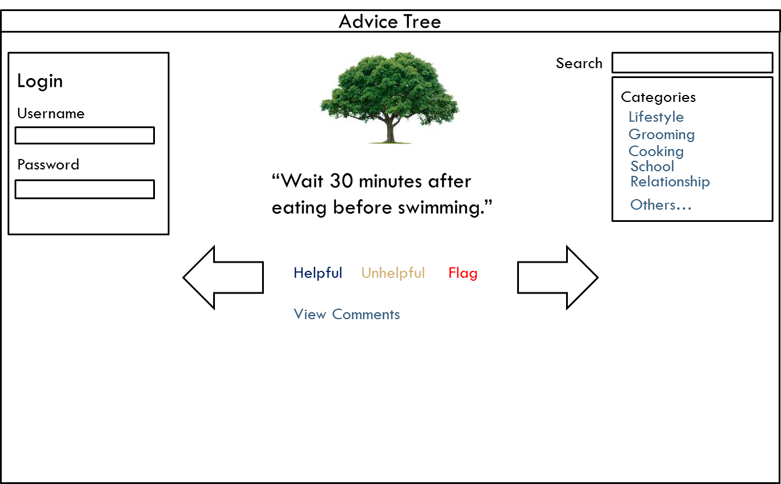

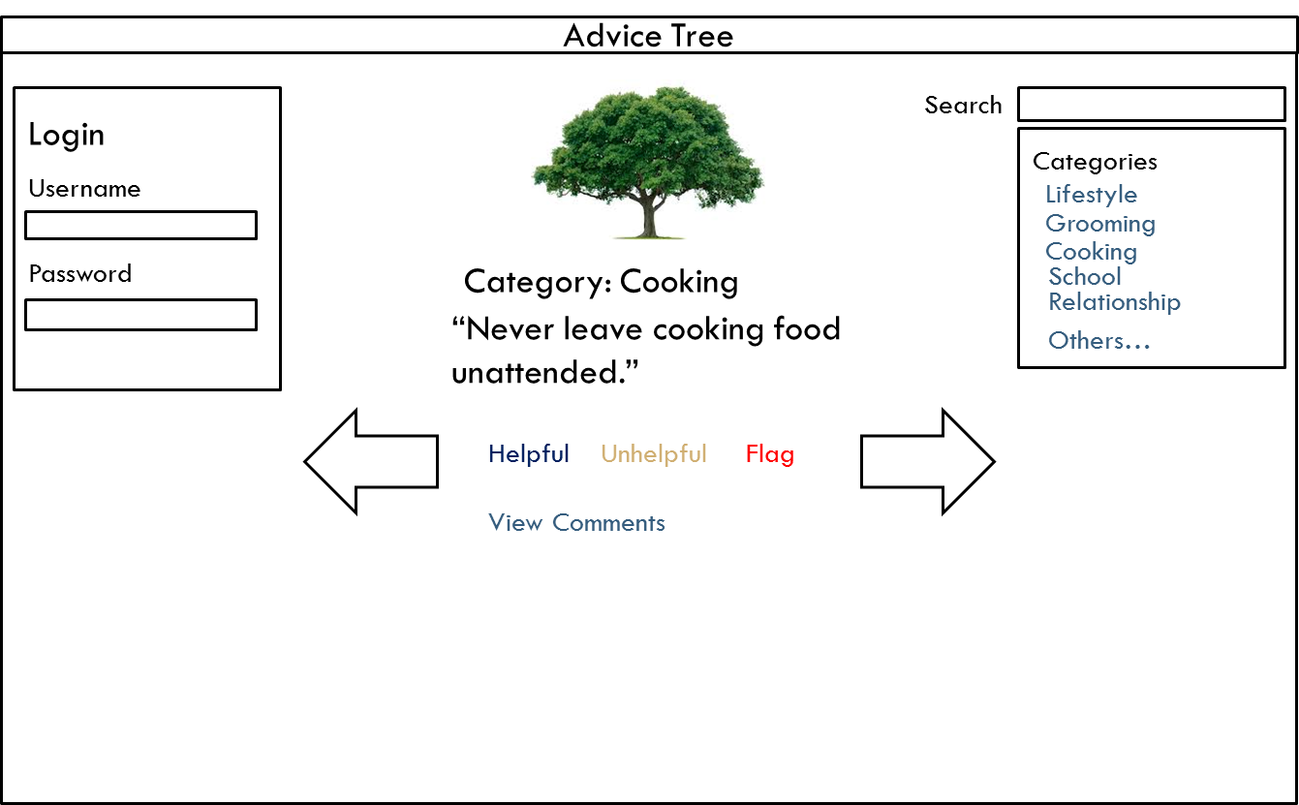

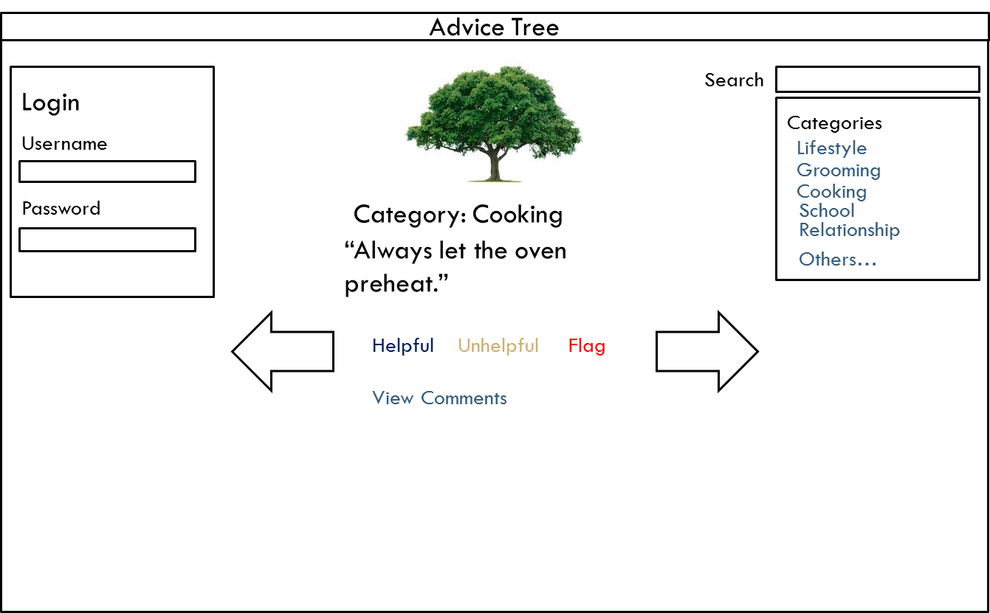

A.1 Add Advice

The following images show the user interface as seen by a user logging into the system and adding an Advice.

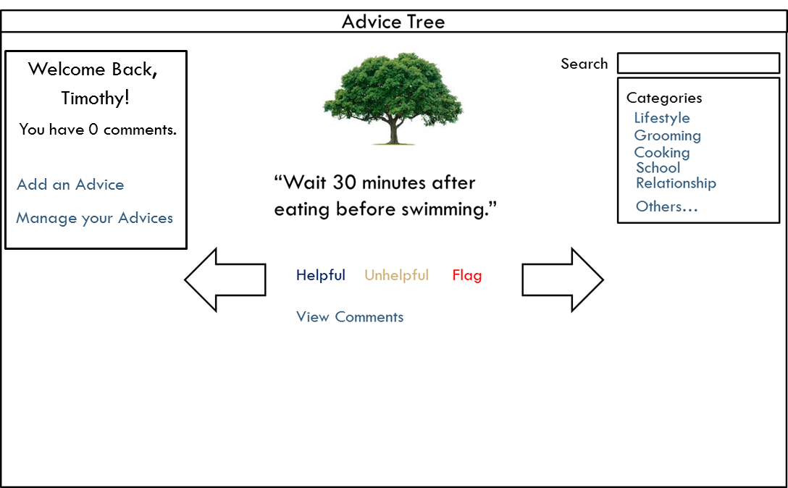

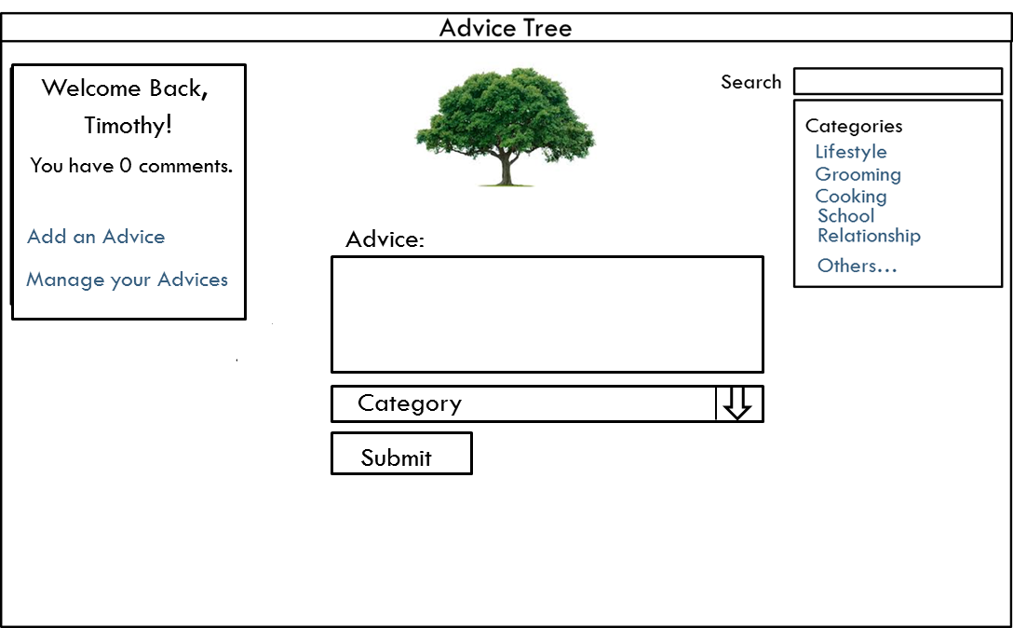

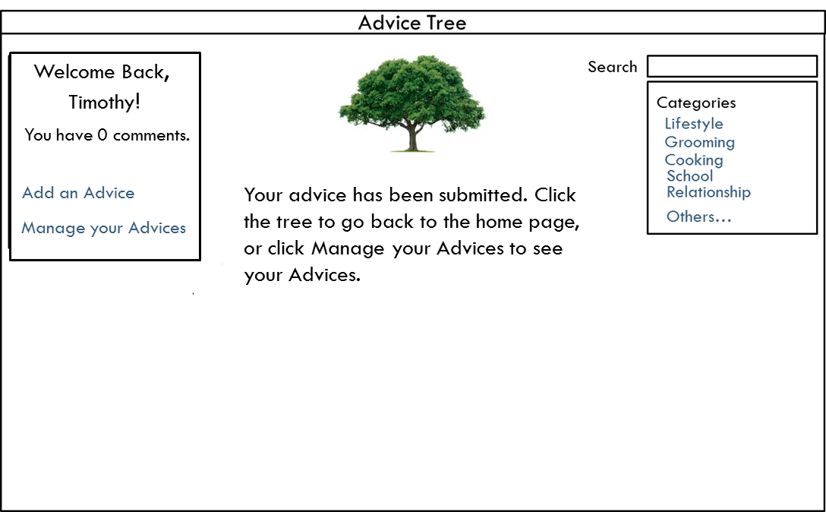

Appendix B: Initial Task and Role Assignments

Initial presentation assignments
Requirements Christian Morrison
Design Timothy Cao & Dale Alberts
Final Ben Holley & Taylor Comer

Initial task assignments
Timothy Cao: User interface design, Database Creation and management
Ben Holley: Functionality design, System tools
Taylor Comer: Functionality design, Quality Assurance
Dale Alberts: User interface design, Quality Assurance
Christian Morrison: Functionality design, System tools

